What Adventurous Activities Can I do? - What Qualification do I need? Revised: Oct 2020
Activity | Type | Section | My Training | Minimum  Qualification Required | e-Learning  Required | Practical or  Course | RPL
BUSHWALKING |  |  | I have a Certificate of Proficiency
 | For basic tracked or easy untracked, bushwalking  e.g. marked trails, Nature walks, National Parks marked trails | For all sections | SP – Safe Participant Bushwalking is part of the Scouting Adventure curriculum. Higher levels are available in difficult tracked & extremely difficult tracked environments. | Safe Participant  or  (old Bushwalking Level 1 ) | Scouting Adventure  12 Modules  Pre & Post Quiz’s are available if you already have the knowledge | Face-to-face weekend are run at various levels – Tracked, Difficult Tracked and Extremely Difficult untracked environments. see Branch calendars for more info | Complete e-Learning component for Scouting Adventure, this will allow for Pre & Post Quiz if you already have the knowledge, instead of completing the modules. a logbook is required as part of your evidence. An Assessment of proficiency document is available.
PADDLING - Canoeing , Kayaking & Sea Kayaking
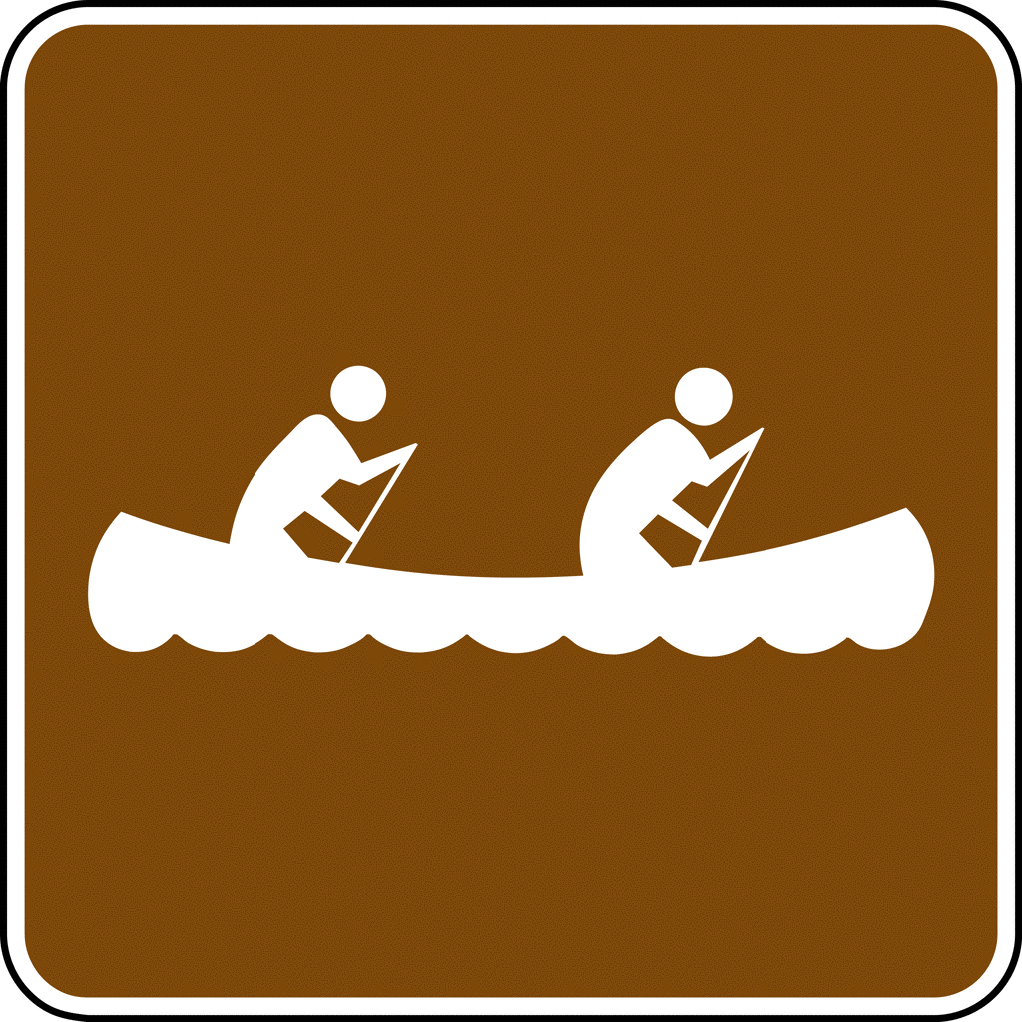 | For Flat Water Canoeing, on rivers, lakes, and open water - Not suitable for fast running or graded water | For all sections | Not included in Basic training. e-Learning & practical is required with your logbook | Trained Participant  In the crafts  Being used  e.g. Canoe, Kayak | Scouting Adventure  Plus  Safe Participant Canoeing/Kayaking | Complete Trained Participant. This can be completed on-the-job and signed off by an appropriate member within your Branch | Complete e-Learning component for Scouting Adventure plus an additional module for Paddling Skills.  Evidence for the Skills, Knowledge, and Currency within Paddling
BOATING – Sailing, Scout Patrol Boats, Windsurfing, Stand-Up Paddleboard, & Windsurfing
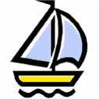 | Sailing in small boat yachting in light to moderate conditions | For all sections | Not included in Basic training. e-Learning & practical is required with your logbook. Attending activities and building skills, knowledge and experience | Trained Participant  In the crafts  Being used  e.g. Sailing, Patrol Boats | Scouting Adventure | Complete Trained Participant. This can be completed on-the-job and signed off by an appropriate member within your Branch. Logbook required | Complete e-Learning component for Scouting Adventure.  Evidence for the Skills, Knowledge, and Currency within Sailing. Verification through a 3rd part declaration, or other supporting material e.g. trip notes, photos, sailing club results, Video, etc.
VERTICAL - Rock Related Activities
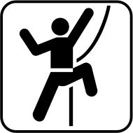 | Abseiling  Caving  Canyoning  Rock Climbing | For all sections | Not included in Basic training. e-Learning & practical is required with your logbook. Attending activities and building skills, knowledge and experience | Scout Appointed Guide for all Rock Related Activities | Scouting Adventure  Plus  Safe Participant Abseiling | All Vertical areas require experience in various environments over a period of time. This can be obtained by on-the-job, activities, or structured learning. | Complete e-Learning component for Scouting Adventure plus an additional module for Abseiling.  Evidence for the Skills, Knowledge, and Currency within your vertical discipline.
Question: What if I want a higher Level or qualification e.g. Canoeing in moving water or sailing, or I want to run a large sale activity?
Answer: You may need a Guide level which requires more training, I suggest you talk to your Branch Adventurous Activity Team. Refer to the NAAF
Any Guide or higher-level qualification will require VET units issued from SAIT or externally gained, this involves an enrolment process via your Branch office
Activity | Type | Section |  | My Training | Minimum  Qualification Required | e-Learning  Required |  | Courses & Comments  On various environments | RPL
CYCLING - Mountain Biking & Cycle Touring |  |  |  | I have a COAL
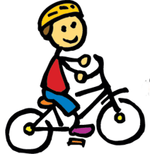 | Refer to the track difficulty rating system, for the level of skill to qualification required. No qualification required for Meeting nights or local urban area. |  | For all sections | Not included in Basic training. e-Learning & practical is required with your logbook. Attending activities and building skills, knowledge and experience | Trained Participant  In the bikes  being used  e.g. Cycling, Mountain Biking | Scouting Adventure |  | Complete Trained Participant. This can be completed on-the-job and signed off by an appropriate member within your Branch. Logbook required | Complete e-Learning component for Scouting Adventure.  Evidence for the Skills, Knowledge, and Currency within Cycling. Verification through a 3rd part declaration, or other supporting material e.g. trip notes, photos, club results, Video, etc.
AQUATIC – Snorkelling, Surfing, Swimming, Scuba – NOTE: Scuba requires a Instructor Qualification at any level of participation
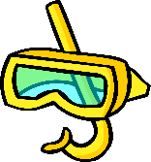 | Swimming in pools, Surf or open water does not require a qualification if a lifeguard is present. For Aquatic activities e.g. Snorkelling Windsurfing, etc. |  | For all sections | Not included in Basic training. e-Learning & practical is required with your logbook. Attending activities and building skills, knowledge and experience | Trained Participant | Scouting Adventure |  | Complete Trained Participant. This can be completed on-the-job and signed off by an appropriate member within your Branch. Logbook required | Complete e-Learning component for Scouting Adventure.  Evidence for the Skills, Knowledge, and Currency within your aquatic discipline. Verification through a 3rd part declaration, or other supporting material e.g. trip notes, photos, club results, Video, etc.
ALPINE – Snow Camping/Hiking, Cross Country Skiing, Down Hill Skiing, & Snowboarding
 | Skiing & Snowboarding within resort boundaries does not require qualifications. For All Alpine activities outside a resort including hiking, cross country etc. |  | For all sections | Not included in Basic training. e-Learning & practical is required with your logbook. Attending activities and building skills, knowledge and experience | Scout Appointed Guide  in the alpine  discipline  e.g. Cross Country, | Scouting Adventure |  | All Alpine areas require experience in various environments over a period of time. This can be obtained by on-the-job, activities, or structured learning. | Complete e-Learning component for Scouting Adventure.  Evidence for the Skills, Knowledge, and Currency within your alpine discipline. Verification through a 3rd part declaration, or other supporting material e.g. trip notes, photos, club results, Video, etc.
Other Questions relating to appointments and what I can do
Qualification or Skill held |  | What am I able to do |  |  |  | Comments
Trainee Leader (leader of Youth) |  | - Able to work ONLY under the direct supervision of other leaders  - Participate in planning with other leaders  - Attend training courses, Group Councils, Seeonee or other meetings |  |  |  |  | Supervising Leader must hold a CoAA (Certificate of Adult Appointment) as a minimum
Subject Matter Expert (SME) |  | - Able to run an activity where they hold qualifications in that activity area  - Able to sign off on workbooks, where the same or higher qualification is held, can hold external VET qualifications |  |  |  |  | Supervising Leader must hold a CoAA (Certificate of Adult Appointment) as a minimum  Someone in the activity must hold a current first aid qualification
Major Event or Activity |  | - Generally, a Branch Scout Appointed Guide are required to run a Major Event or Activity  - Due to the nature of a Major Event, and supervising those assisting, and the increased risk, a higher than normal qualification is required. |  |  |  |  | Supervising Leader must hold a CoAA (Certificate of Adult Appointment) as a minimum  Someone in the activity must hold a current first aid qualification

