Dear {insert teacher/ Principal name},

{student full name} has been selected to attend Kandersteg International Scout Centre (KISC) as part of the Australian Contingent from July 1 – 13, 2023.

Scouts Australia is sending a Contingent of 231 lucky youth members from across the country to KISC, situated in the heart of Switzerland, to celebrate the centenary of the site which opened in 1923.

This is a huge opportunity and privilege for {student first name} to experience personal development opportunities that are adventurous, fun, challenging and inclusive. The program is based on a system of progressive non-formal education made up of elements which work together to provide a rich, active, and fun learning environment.

Whilst this travel may interrupt participants’ school or university commitments, the deep personal development that will occur for these Scouts will be second to none. We urge you to support participants at your educational institution who have been lucky enough to secure a position as part of our Contingent.

Please don’t hesitate to get in touch with me by emailing lisa.picking@scouts.com.au should you have any questions.

Kind regards,
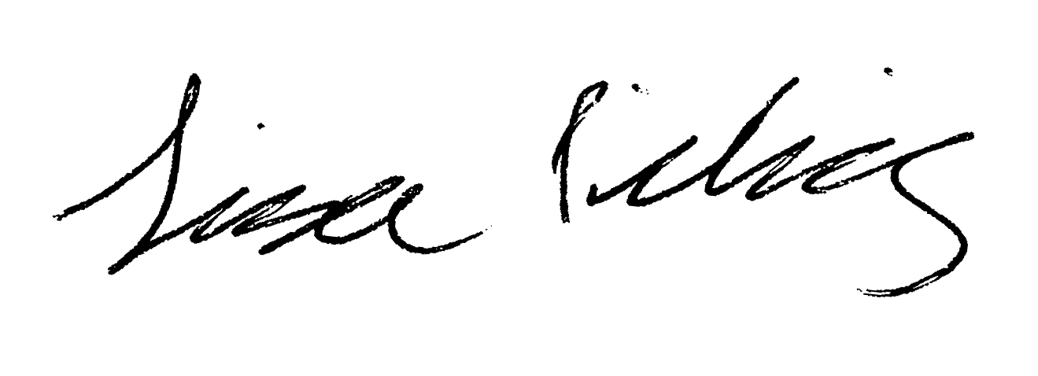

Lisa Picking
Australian Contingent Leader
KISC100
https://scouts.com.au/event/kisc100/

